**Database Programming**

**Name: Sakshi Jain Student Id: c0753352**

**Exercise 4 (1.2%)**

**Instruction: Include FULL Screenshot that display your code and output on SQL Developer or Live SQL**

**Write PL/SQL block that will display your first name, last name , name of your favorite programming course.**

DECLARE

firstName varchar(30);

lastName varchar(30);

course varchar(30);

BEGIN

firstName:= 'Sakshi';

lastName:='Jain';

course:= 'database Programming';

dbms_output.put_line('My First Name Is:' || firstName);

dbms_output.put_line('My Last Name Is:' || lastName);

dbms_output.put_line('My Favorite programming Course Is:' || course);

END;

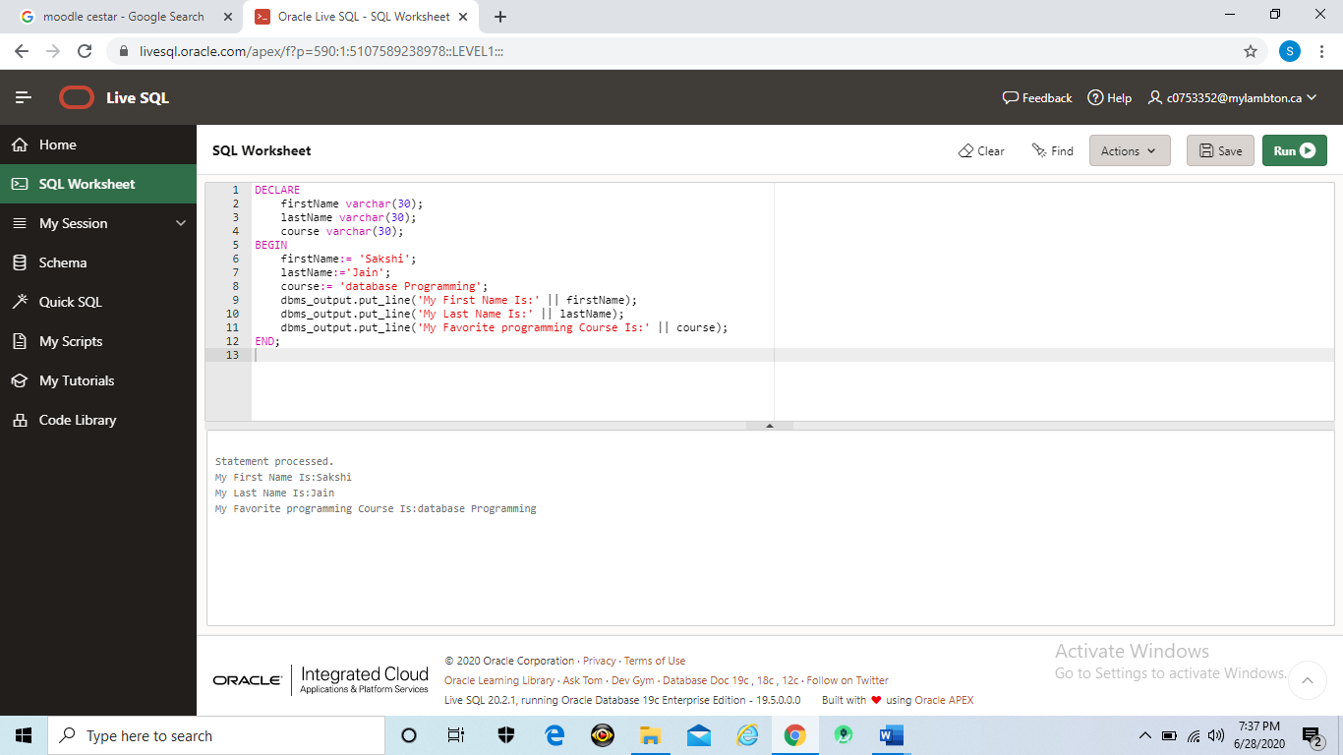

**Exercise 5 (1.2%)**

**Instruction: Include FULL Screenshot that display your code and output on SQL Developer**

**a)Write PL/SQL block that will display the last name, salary and hire date for employee id 101**

DECLARE

v_last_name varchar(25);

v_salary number(10,2);

v_hire_date varchar(25);

BEGIN

select last_name, salary, hire_date

INTO v_last_name, v_salary, v_hire_date

FROM hr.employees

where employee_id = 101;

dbms_output.put_line(v_last_name);

dbms_output.put_line(v_salary);

dbms_output.put_line(v_hire_date);

END;

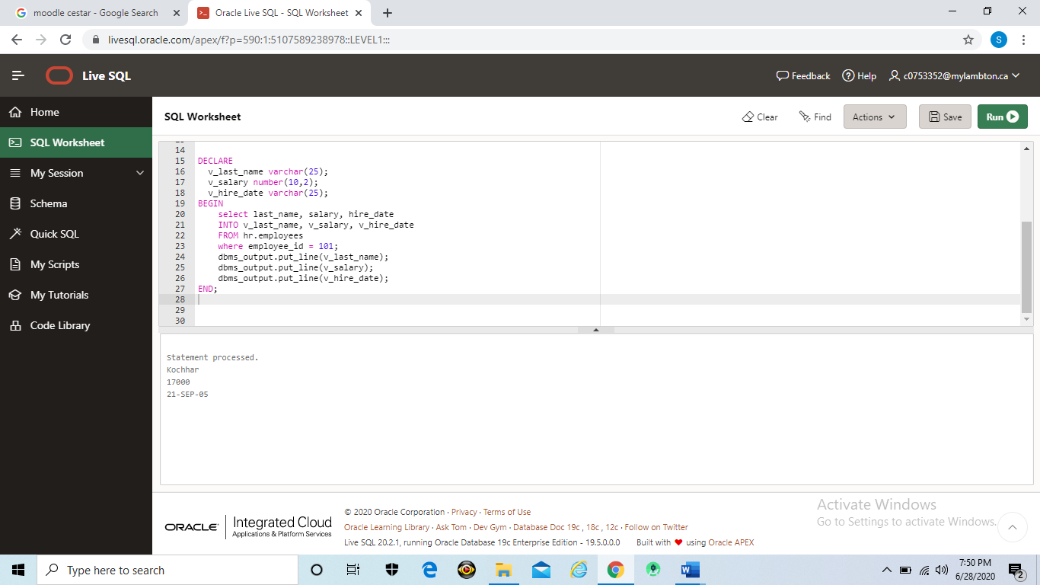

**b)Write PL/SQL block that will display the last name, salary the recent hire date for department 60**

DECLARE

CURSOR new_cursor IS SELECT last_name, salary, hire_date FROM hr.employees where department_id=60;

v_last_name hr.employees.last_name%TYPE;

v_salary hr.employees.salary%TYPE;

v_date hr.employees.hire_date%TYPE;

BEGIN

open new_cursor;

loop

fetch new_cursor into v_last_name, v_salary, v_date;

exit when new_cursor%notfound;

dbms_output.put_line('last_name:' || v_last_name);

dbms_output.put_line('salary:' || v_salary);

dbms_output.put_line('recent hire date:' || v_date);

end loop;

close new_cursor;

end;

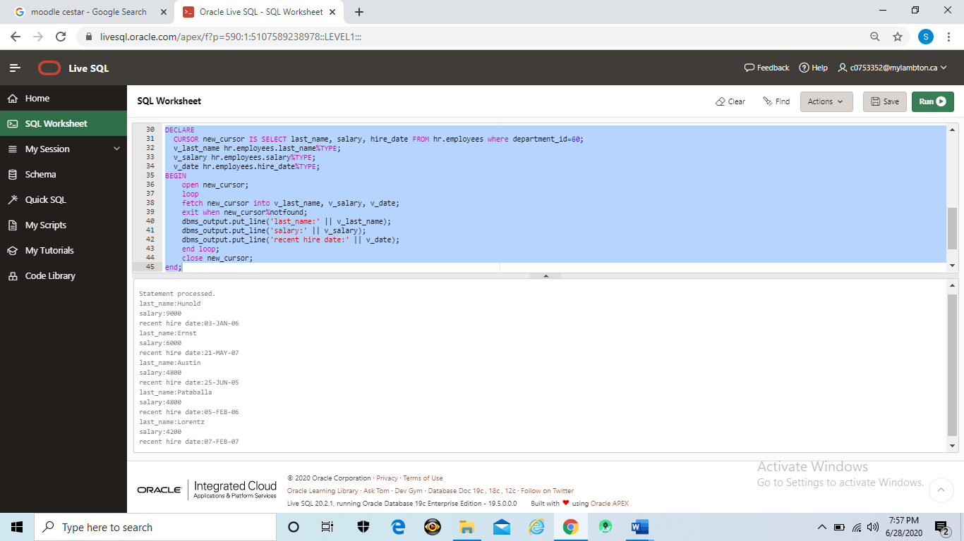

**Exercise 6 (1.2%)**

**Instruction: Include FULL Screenshot that display your code and output on SQL Developer**

**Write PL/SQL block that will insert new department id in the department table in HR database as following:**

**Department_id = 290 and Department_name=’Information Technology. Write select statement to show the inserted row.**

**Department_id = 300 and Department_name= ‘Procurement’. Write select statement to show the inserted row.**

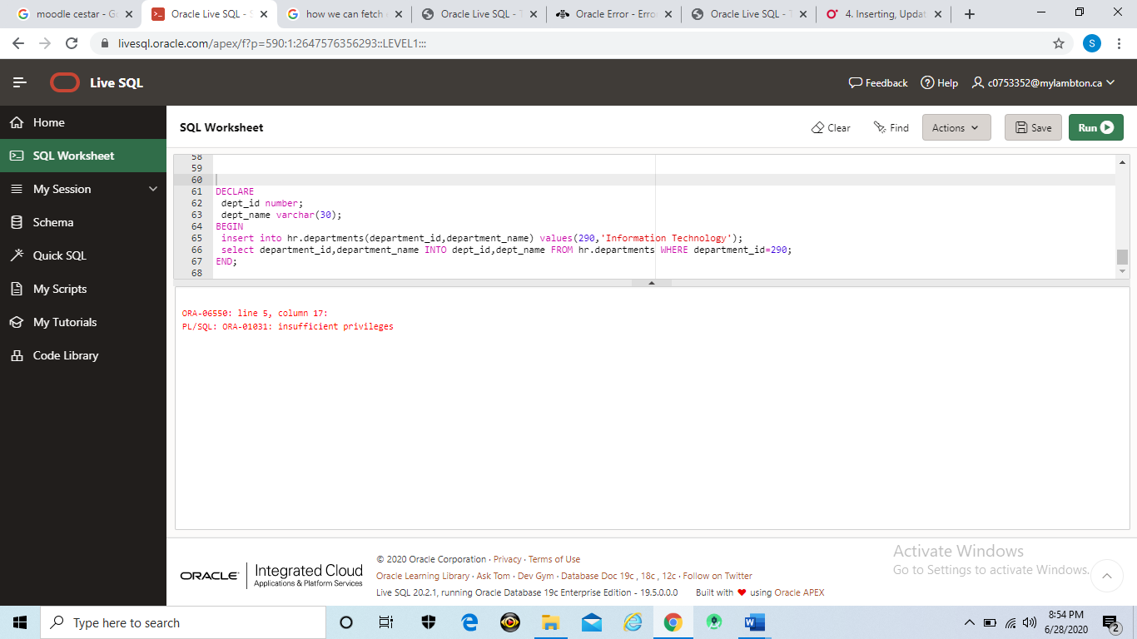

**create table Department(dept_id number,dept_name varchar(30));**

**insert into Department(dept_id,dept_name) values(290,'Information Technology');**

**select dept_id,dept_name from Department where dept_id=290;**

**insert into Department(dept_id,dept_name) values(300,'Procurement');**

**select dept_id,dept_name from Department where dept_id=300;**

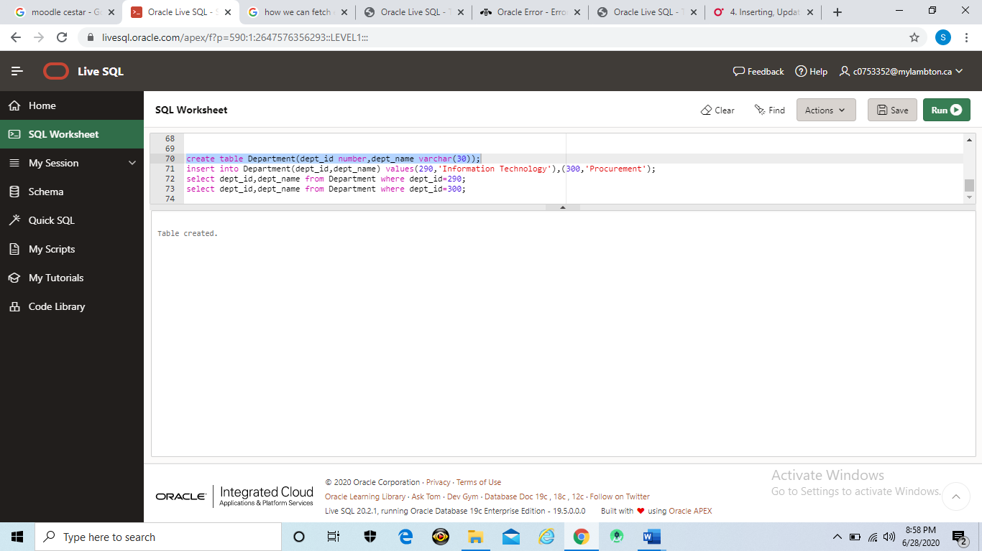

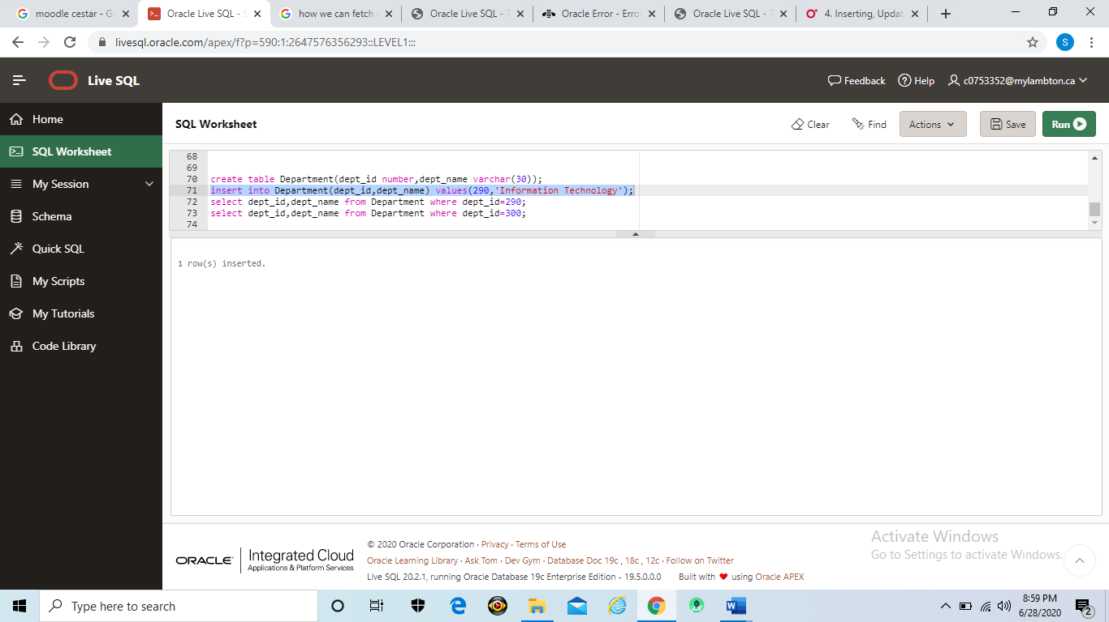

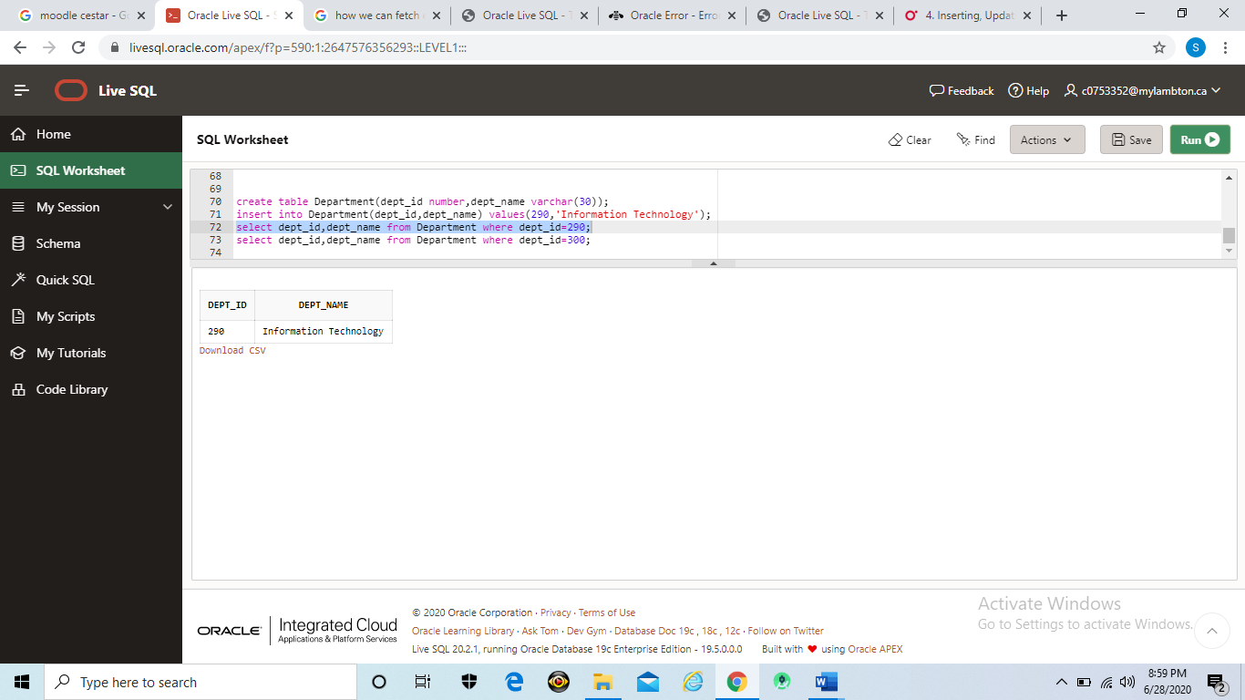

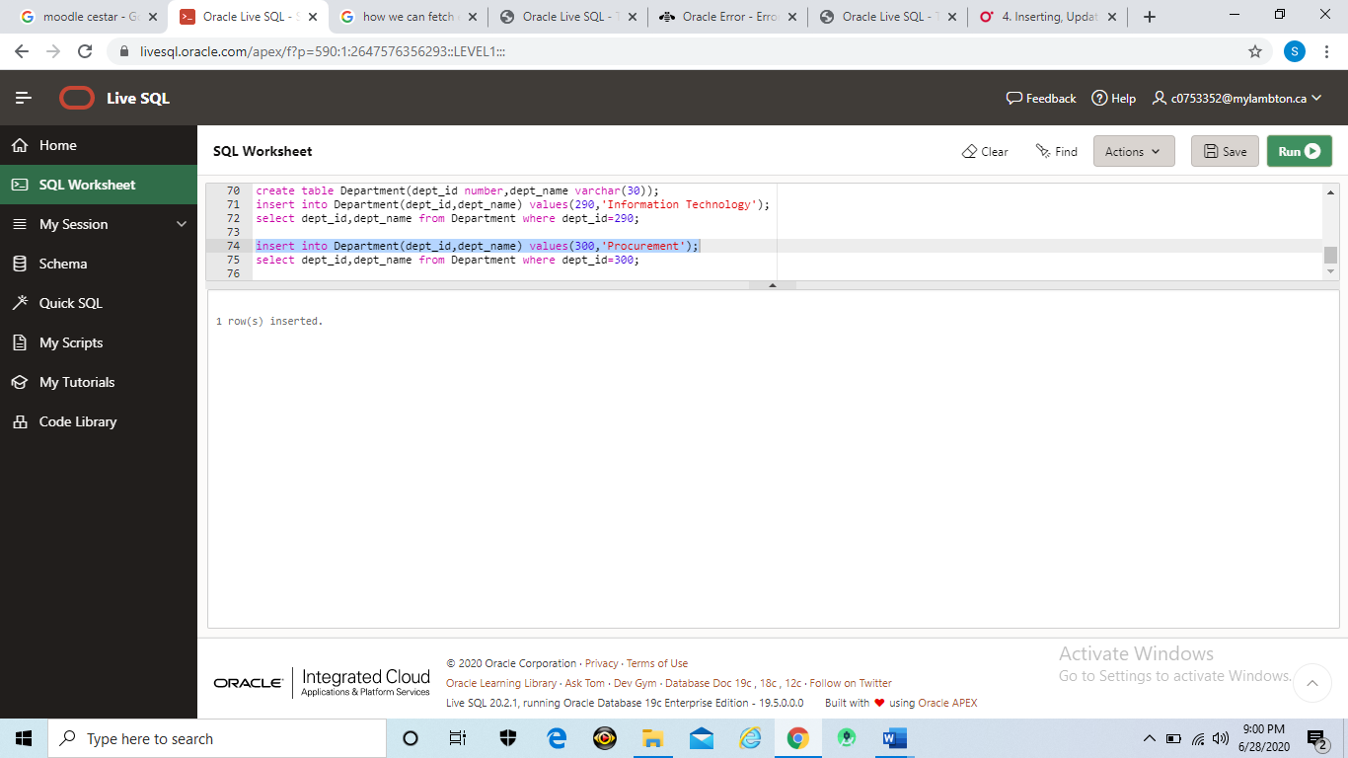

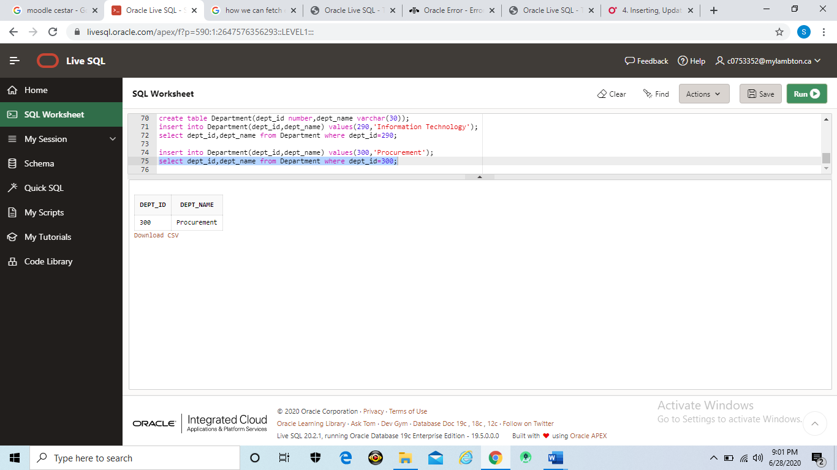

**Exercise 7 (1.2%)**

**Instruction: Include FULL Screenshot that display your code and output on SQL Developer**

**Write PL/SQL block that will display the highest and lowest employee salary in department_id 60.**

DECLARE

high_salary number(15,2);

low_salary number(15,2);

BEGIN

select MAX(salary), MIN(salary)

INTO high_salary, low_salary

FROM hr.employees

WHERE department_id= 60;

dbms_output.put_line('Maximum Salary is:' || high_salary);

dbms_output.put_line('Minimum Salary is:'|| low_salary);

END;

